**THE SAVINGS FOR LIFE PROGRAM**

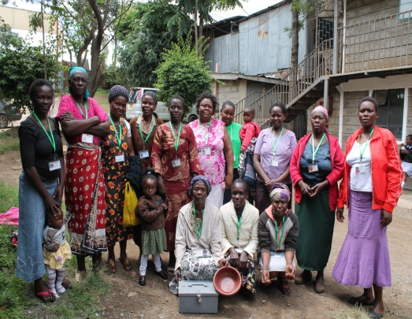SFL is integral to the fulfillment of MCO’s mission to “transform the community with the gospel of love.” Towards this end, the program seeks to empower the community economically as well as spiritually. It a savings-led Micro finance program which adopts the use of the Village Savings and Loan Association methodology focused on promoting community-based savings and credit groups. The V S L A methodology builds from an indigenous model that communities have used for centuries in order to manage their finances. The SFL model emphasizes provision of simple and accessible financial services, to the vulnerable and poor communities in the rural and peri - urban areas of Africa

The SFL program is now 3 years old since inception with a staff of 4. Our goal is to reach 5000 member participants with their families approx. 25,000 members, SFL has so far attracted and trained 95 groups of over 1,500 members.

Members of Tujijenge SFL Group

Additionally, volunteers from the churches and the community serve as Community Agents mobilizing and training savings groups, taking on this responsibility as a ministry of the church.

The newly developed SFL Bible Study seeks to generate spiritual transformation, not simply financial, or physical transformation through savings activities alone. The 32-week Bible Study explores the restoration God desires within man’s four key relationships: Man with God, others, the environment, and himself.

It also focuses on character development with regard to stewardship, personal finance and one’s attitude towards work. The Bible Study offers an opportunity for group members to surrender their lives to Christ and to commit themselves to righteous living.

A lot of impact and lessons have been documented as a result of implementing SFL in Mathare Slums since inception and these include:

1. Improved saving culture of the poor and the vulnerable in the communities of peri-urban Kenya like Mathare Valley
2. Increased incomes
3. Spiritual growth
4. Improved livelihoods (nutrition, clothing, etc)
5. Improved capacity to meet requirements like medical and education (school fees)
6. Increased asset accumulation notably like furniture for home, radios, mobile phones and business expansion
7. Improved social networks and capacity to take up leadership roles at community level by SFL members especially by women.
8. Improved self-esteem and control of household resources especially by women.

Successful SFL implementation has been a result of well-planned coordination, provision of technical assistance to implementing staffs, monitoring and evaluation, information dissemination, assuring quality, sustainability, and encouraging cross-learning among implementing agencies. Provision of technical support to implementing staff involves planning and executing trainings on the SFL methodology, monitoring and evaluation, funding support, constant mentoring and coordination.

Training on SFL methodology is the initial step in implementation of SFL activities and it is aimed at imparting knowledge and skills to targeted SFL trainers so that they in turn have the capacity to mobilize, form, train and monitor SFL groups. This integration is expected to result into improved livelihoods, improved incomes resulting into improved ability of care takers to send children to school, reduced cases of child abuse and child labor.

**PLAN FOR 2017**

Planning forward in 2017, we are in the process of identifying networks that will work together with the current SFL groups to form an association. This will act as a platform for the members to voice the social issues that have become part of their lives.

Our point of reference is from the book of Proverbs **30:24-25** which says; *four things on earth are small yet they are extremely wise: ants are creatures of little strength, yet they store up their food in the summer.*